**Project Report: Electric Vehicle Market Segmentation**

**By Mohammed Ehtesham Aleem**

**Abstract:** The Indian automotive market is at a pivotal juncture with increasing interest in sustainable mobility. This report uses segmentation analysis to identify and target market segments most likely to adopt electric vehicles (EVs). By leveraging clustering techniques, we provide insights into customer profiles and propose a feasible market entry strategy.

**1. Introduction**

The global push towards sustainability and the rising fuel costs have made EVs a promising alternative in India. However, the diversity in consumer demographics and purchasing behaviours necessitates a targeted approach. This report analyzes the Indian EV market using segmentation analysis to identify optimal target segments.

**2. Methodology**

The analysis employs:

* **Data Collection:** Data includes demographics, income levels, geographic distribution, and preferences for EV adoption.
* **Clustering Algorithm:** The K-Means algorithm, with preprocessing steps like scaling and PCA, was used to identify clusters.
* **Cluster Validation:** The Elbow Method and silhouette scores ensured robust cluster formation.

**Market Overview**

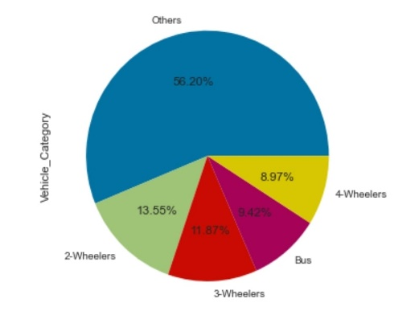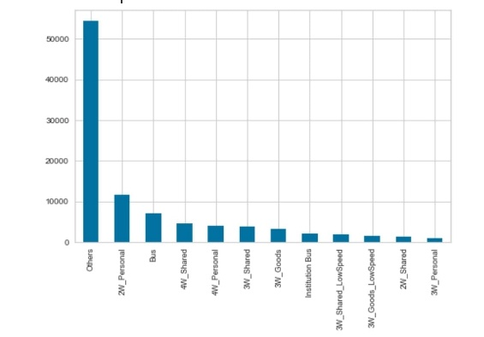

**Distribution of Vehicle by Category**

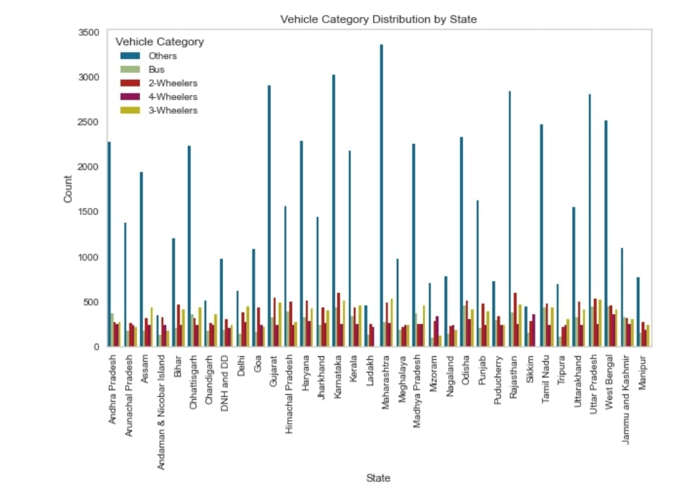

**Distribution of Vehicle Category by State**

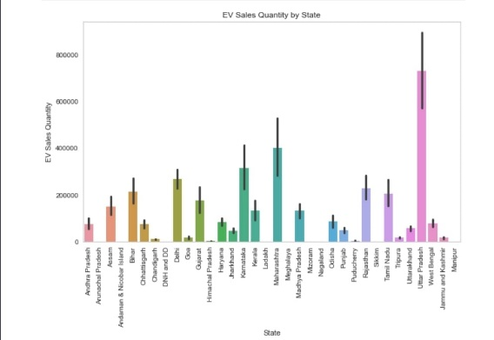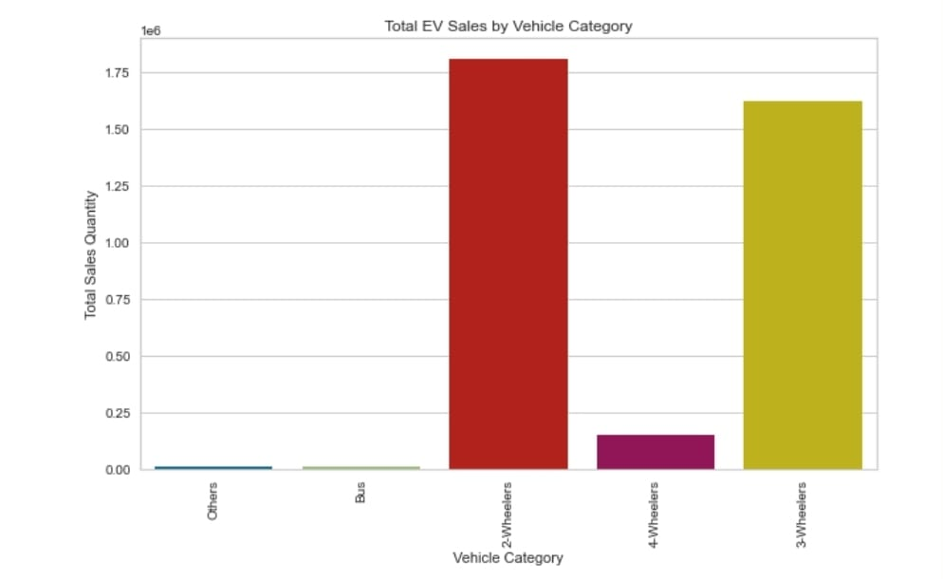

**Sales of EV by State and Category**

**3. Key Findings**

**3.1 Optimal Clustering:** Using the Elbow Method, the ideal number of clusters was determined to be four. Each cluster represents a distinct consumer group.

**3.2 Cluster Profiles:** The segmentation analysis revealed five distinct consumer groups, each with unique characteristics, purchasing behaviours, and motivations for EV adoption.

Cluster 0 comprises high-income, urban early adopters who possess significant purchasing power and strong environmental awareness. This group is concentrated in metropolitan cities and is drawn to premium EV models that offer advanced technology, luxury features, and superior performance. Their willingness to pay a premium for sustainable options makes them an ideal target for high-end EVs.

Cluster 1 includes mid-income, urban, environmentally conscious individuals who are moderately price-sensitive. This group values sustainability but operates within a constrained budget. Members of this cluster are primarily professionals and small business owners residing in urban areas. They are likely to adopt mid-range EV models if supported by government subsidies or attractive financing options. Marketing efforts for this segment should emphasize cost-effectiveness and long-term savings.

Cluster 2 consists of low-income, rural, price-sensitive consumers. This segment has limited disposable income and low awareness of the environmental and economic benefits of EVs. They primarily rely on two-wheelers or three-wheelers for their daily commute. Affordable EV options, such as low-cost scooters or shared transportation solutions, can address the needs of this group. Education campaigns and incentives will play a critical role in fostering adoption within this cluster.

Cluster 3 represents family-oriented, suburban residents who prioritize practicality, long-term savings, and reliability. This group typically comprises middle-aged individuals with families who need spacious and cost-efficient vehicles for daily commuting and occasional long drives. Marketing strategies for this segment should highlight the affordability of ownership, safety features, and family-friendly design elements.

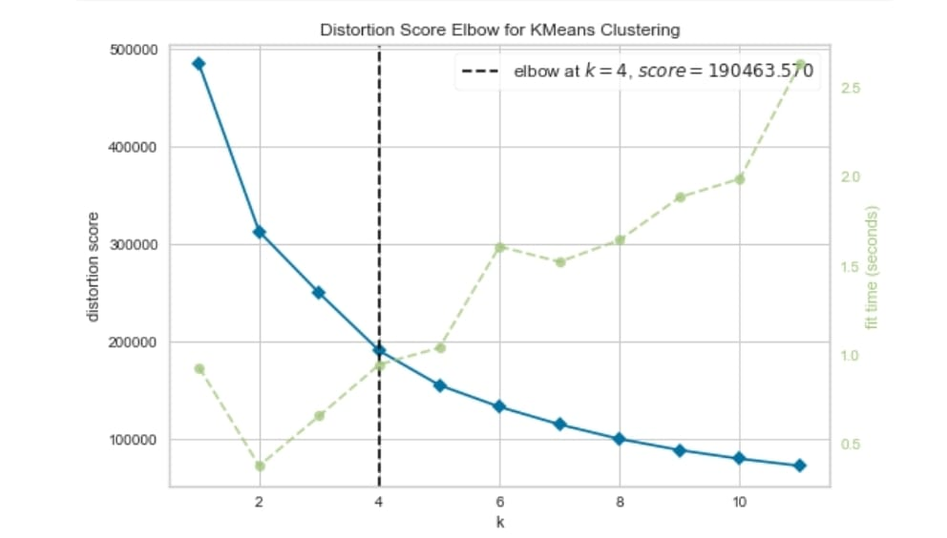**Distribution Score Elbow for K-Means Clustering**

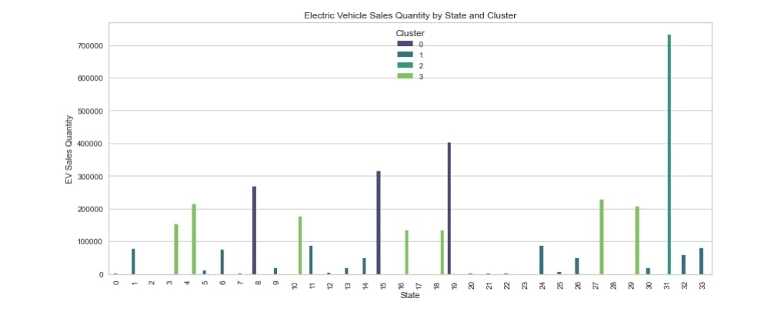

**EV Sales Quantity by State and Clusters using K-Means Clustering**

**4. Feasible Market Entry Strategy**

**4.1 Market Segmentation Focus:** Based on the analysis, Clusters 1 and 2 should be prioritized for the initial market entry. These segments demonstrate a combination of readiness for EV adoption, financial capability, and alignment with sustainability goals.

**4.2 Strategic Recommendations:**

1. **Product Offering:**
   * Develop a diverse product line to cater to the unique needs of different clusters. For Cluster 1, focus on premium EV models with high-end features and luxury branding. For Cluster 2, introduce mid-range EVs that balance quality and affordability. Expand offerings to include low-cost two-wheelers and three-wheelers for Cluster 3, enabling rural penetration.
2. **Marketing and Awareness:**
   * Implement targeted digital campaigns aimed at tech-savvy and environmentally conscious individuals in Clusters 1 and 4. Highlight the luxury, innovation, and environmental benefits of EVs. For Cluster 3, conduct awareness drives in rural areas to educate potential buyers about the economic and environmental advantages of EVs. Leverage traditional media and community programs to build trust and interest.
3. **Incentives and Partnerships:**
   * Collaborate with the Indian government to offer attractive subsidies and tax benefits for EV buyers, particularly targeting mid-range and low-cost models. Partner with financial institutions to provide affordable financing solutions, including low-interest loans and flexible payment plans. Develop strategic alliances with technology companies to enhance connectivity features and improve user experience.
4. **Infrastructure Development:**
   * Prioritize the expansion of EV charging infrastructure in urban and suburban areas to reduce range anxiety among potential buyers. Work with local governments and private players to establish a comprehensive network of charging stations. Offer home charging solutions and installation services to enhance convenience for residential buyers.

**5. Recommendations for the Startup Company for Market Entry**

**Focus on Segments with High Adoption Potential:**

* **Target Clusters 1 and 2 Initially:**
  + Cluster 1 (mid-income urban professionals): Develop mid-range EVs emphasizing affordability, long-term savings, and sustainability. Highlight benefits like cost-efficiency and government subsidies.
  + Cluster 2 (low-income rural users): Offer low-cost two-wheelers or three-wheelers tailored to rural commuting needs. Provide incentives and education on EV benefits.

**Product Development Strategy:**

* **Affordable Range**: Design low-cost vehicles with essential features for rural markets.
* **Mid-Range Solutions**: Focus on quality, affordability, and innovative financing options to appeal to urban middle-income users.
* **Premium Options**: Introduce high-tech, luxury EV models for high-income urban users (Cluster 0) in later phases.

**Marketing Approach:**

* Leverage digital campaigns targeting environmentally conscious urban consumers.
* Conduct rural education campaigns to build awareness and interest in affordable EV solutions.

**Phased Expansion:**

* Begin with urban and suburban markets where infrastructure and purchasing power are more robust.
* Gradually extend into rural areas with an emphasis on affordability and accessibility.

**6. Conclusion**

The Indian EV market presents immense opportunities for growth and innovation. By focusing on the identified clusters and tailoring products and marketing strategies to meet their specific needs, businesses can establish a competitive edge in the market. Addressing critical challenges, such as infrastructure gaps and affordability, will further accelerate EV adoption and ensure long-term success. A phased approach targeting urban and suburban markets initially, followed by rural penetration, will enable sustainable growth and maximize market share.